**Weekly PPG Update 13.10.25**

1. **Stay Well – Winter Campaign**

Here at NHS Dorset we’re gearing up for winter with the new Stay Well campaign.

We’d love to shout about the little things that we can do or are doing to support our communities, that help people to stay well across the winter months.

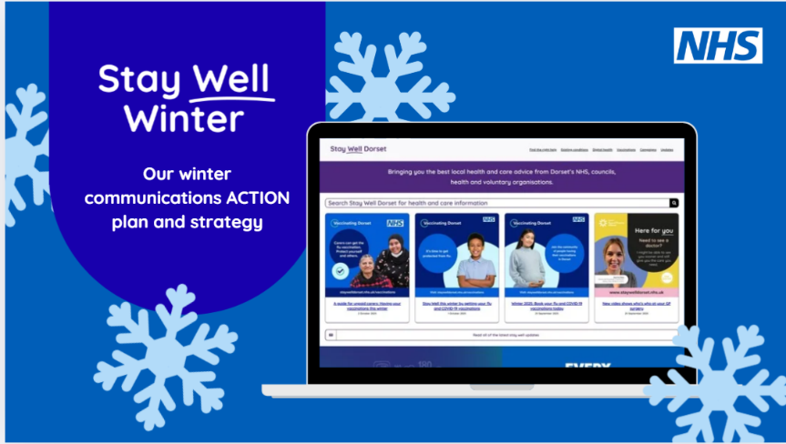

It would be brilliant if you could let us know about anything that’s happening or that you’re aware of that others are doing that might help support local people – whether in terms of prevention, mental health, isolation, accessing support, etc.

If you have anything you’d like to put forward, please could you send it with a photo or video and if possible a quote from someone who has found it beneficial, and we can start sharing and publicising it for you!

1. **Citizens Advice Energy Team – Fuel Poverty Awareness Event**

We would like to invite any community or carer group to come along to the **Fuel Poverty Awareness event** on **Wednesday 4th December 2025** at The Gather, Dolphin Centre, Poole.

This event will bring together local organisations to raise awareness of the challenges of fuel poverty and highlight the wide range of support available to people in our community. It will be an opportunity to:

* Share information about your services with the public.
* Connect with other local organisations tackling related issues such as health, wellbeing, housing, debt, and community support.
* Raise awareness of how residents can access help this winter.

We are keen to bring together a strong mix of partners including community groups, charities, energy organisations, and health and care services.

There is no cost to take part – we simply ask you to bring information/resources for a small display space and be available to engage with visitors during the event.

If you would like to join us, please let us know by **31st October** so we can confirm your place and share further details.

We hope you’ll be able to join us in working together to support our community this winter.

Kind regards,

Carla

Energy Team Admin Support [carla.ellery@edpcitizensadvice.org.uk](mailto:carla.ellery@edpcitizensadvice.org.uk)

--

Carla Ellery

Energy Team Coordinator

Citizens Advice East Dorset & Purbeck

1. **Stroke Association - South West Involvement Network (attachment**)

The Stroke Association has sent through the attached flyer as they are looking to hear from people who are, or who support, a stroke survivor.

More details on the flyer as well as information on how to get in touch.